# **Tasks Related to database, pending and Decline of Death confirmation**

**Task1:** This column should be deleted when declined the Death confrimation notification.

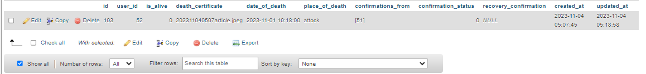

**Task2: This should be reviewed**, after locked profile recovered then this row should be updated.

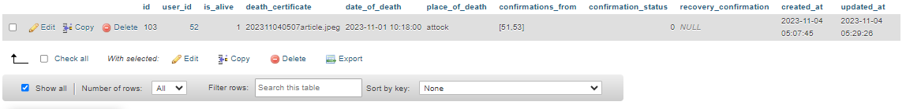

**Task3: this should be reviewed**, this row should be updated when locked profile recovered and then again have death confirmation (in pending) of that same person.

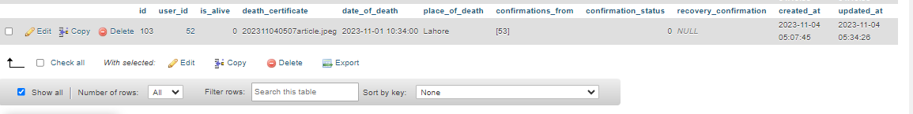

# **Backend Testing**

**Task4: Reject Request Button Not working**

When a user request to someone for relation then reject button is not working for rejection of relation. (working on Contact Relation Notification **Reject button**)

**Task5: Make the profile visible there in messages section.**

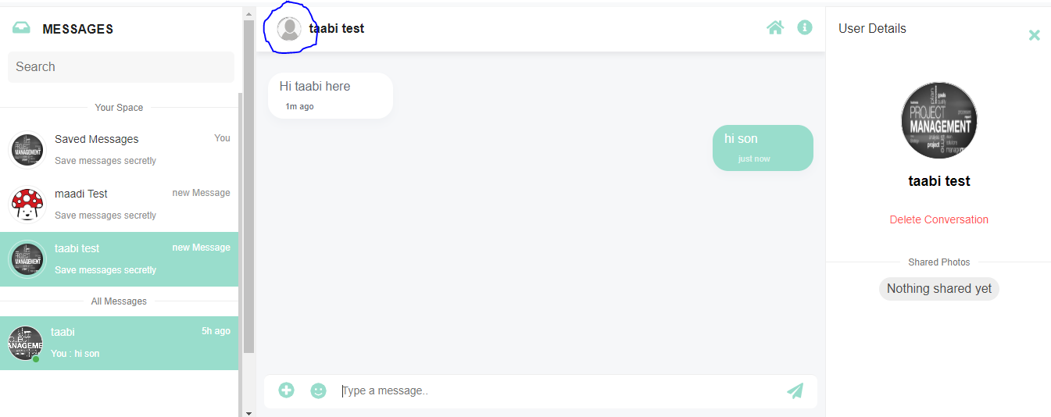

**Task6:** this should be reviewed, this problem is fixed before but now it is not there, this “default pic” for **Test Father** must be there.

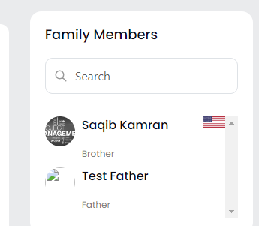

**Task7:** please this when payment is pending then there is no need of ‘**N/A’**.

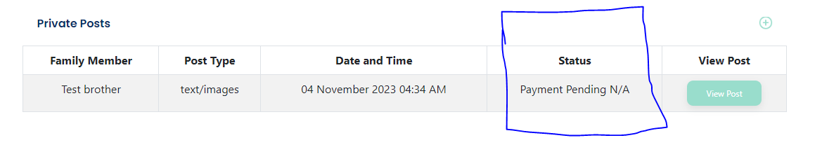

# **Frontend fixes for today**

## **Task1:**

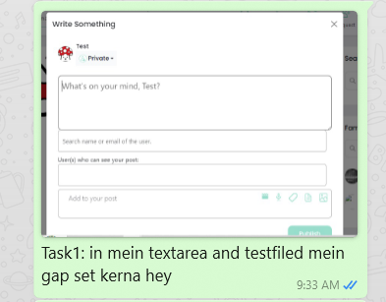

## **Task2:**

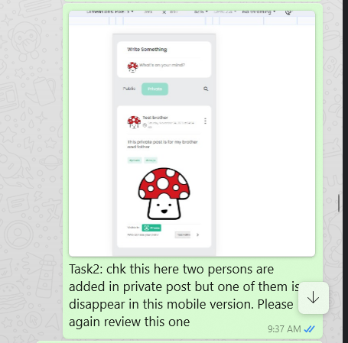

## **Task3:**

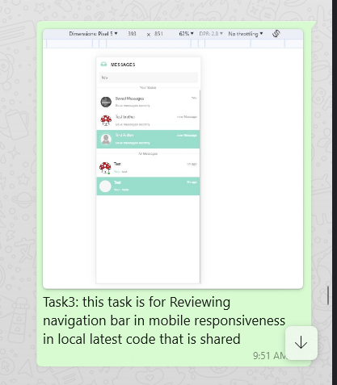

## **Task4:**

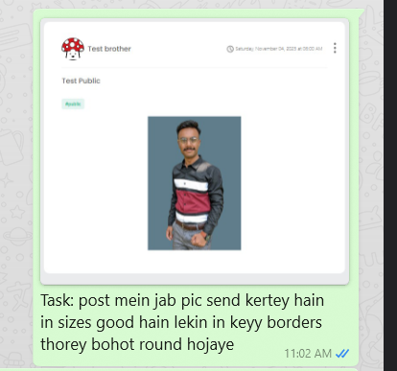

**Task5: When keypad is open for messaging then no name of contact profile is available, visible after scrolling**

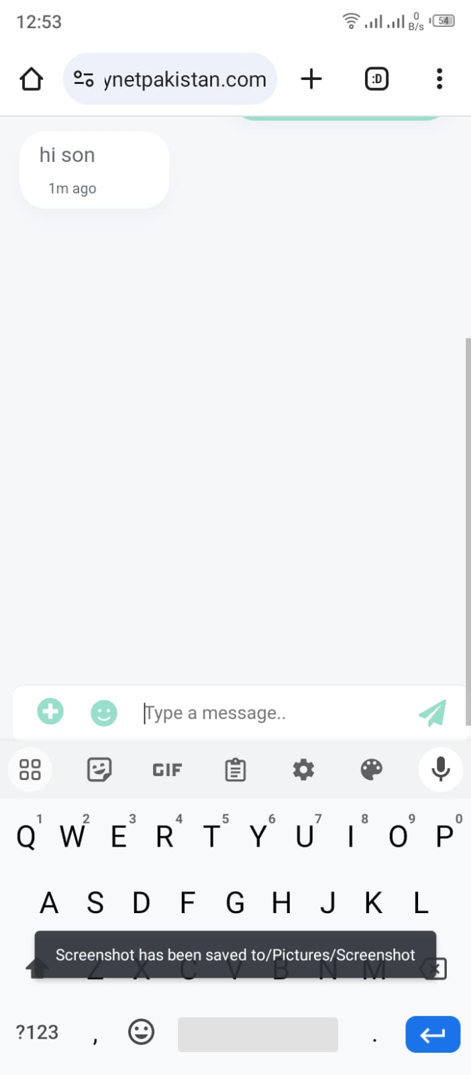

## **Task6:**

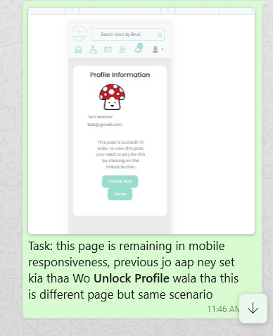

## **Task7:**

